**How Electrical Stimulation Is Used in Physical Therapy**

By [Laura Inverarity, DO](https://www.verywellhealth.com/laura-inverarity-do-2695989)

Updated on July 03, 2024

 Medically reviewed by [Oluseun Olufade, MD](https://www.verywellhealth.com/oluseun-olufade-md-5183759)

Table of Contents

View All

* [Electrical Stimulation](https://www.verywellhealth.com/electrical-stimulation-2696122#toc-what-is-electrical-stimulation)
* [Uses](https://www.verywellhealth.com/electrical-stimulation-2696122#toc-why-e-stim-is-used)
* [What to Expect](https://www.verywellhealth.com/electrical-stimulation-2696122#toc-what-to-expect-during-e-stim)
* [Types](https://www.verywellhealth.com/electrical-stimulation-2696122#toc-types-of-electrical-stimulation)
* [Limitations](https://www.verywellhealth.com/electrical-stimulation-2696122#toc-limitations-of-e-stim)

Electrical stimulation involves sending electrical currents through the skin and into muscles. This may help reduce pain, stimulate tissue healing, and strengthen muscles.

If you have an injury, your healthcare provider may order physical therapy to help you on the road to recovery. Along with other forms of treatment, you may receive [electrical stimulation](https://www.verywellhealth.com/electric-muscle-stimulation-electrostim-297166) as part of your therapy.

Keep reading to learn more about electrical stimulation (e-stim) and how it's used in physical therapy.

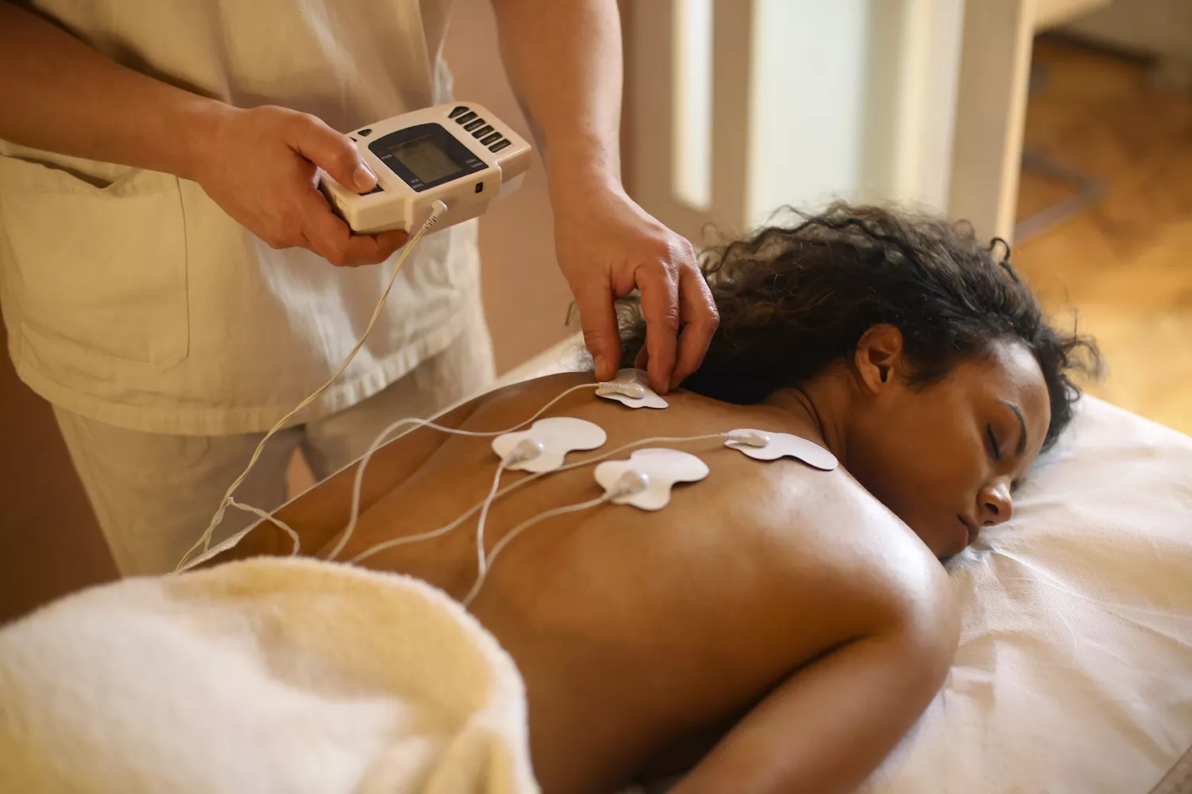

Goodlife Studio / Getty Images

What Is Electrical Stimulation?

Electrical stimulation is a type of [physical therapy modality](https://www.verywellhealth.com/physical-therapy-treatments-and-modalities-2696683) or treatment used to accomplish various tasks in [physical therapy](https://www.verywellhealth.com/physical-therapy-4014670) (PT). The idea is that applying an electrical current helps strengthen muscles, block pain signals, and improve blood circulation.

If you have an injury or illness that causes pain or prevents you from easily moving around, your physical therapist may use electrical stimulation, or e-stim, as a part of your rehabilitation program.

Why E-Stim Is Used

Electrical stimulation is used for many reasons in physical therapy. It can be used to:

* Provide medication for inflammation
* Improve muscles that are weak or not functioning correctly
* Help decrease pain or spasms

If you are experiencing pain, spasms, inflammation, or muscle weakness, your physical therapist may use this treatment to help you.

Some of the medical conditions treated with e-stim include:

* [Low back pain](https://www.verywellhealth.com/10-things-to-stop-doing-if-you-have-low-back-pain-3954666)
* [Post-surgical pain](https://www.verywellhealth.com/what-is-pain-management-296604)1
* Muscle weakness or poor motor control
* Tendonitis
* [Bursitis](https://www.verywellhealth.com/bursitis-inflammation-swelling-joints-2548805)

E-stim has also been used to help treat stubborn wounds.2 A physical therapist who is a wound care specialist would be the professional who provides this treatment for you.

**Debate About E-Stim**

The big question in physical therapy these days is *should electrical stimulation be used?*Electrical stimulation is a relatively passive form of treatment. You do nothing (or very little) while the treatment is being applied.

Most successful rehab programs include *active* participation by the patient. Learning the right movements and exercises for your specific condition is extremely important.

Some professionals debate whether e-stim is something of value in physical therapy.3 And some research shows that electrical stim doesn't help injured people very much. Other research indicates that some types of stimulation can be useful.4

Despite the ongoing debate on whether e-stim truly helps, you may encounter it if you go to physical therapy. So knowing what it is and what to expect can be helpful.

What to Expect During E-Stim

If your physical therapist chooses to use electrical stimulation during your rehab, they should explain the procedure to you. Your physical therapist should also discuss the expected risks and benefits. A typical application of e-stim goes something like this:

1. Your physical therapist applies electrodes to the part of the body that needs treatment. These electrodes are connected through a wire to an e-stim machine.
2. You will feel a slight tingling sensation.
3. The sensation will be increased until it feels strong but comfortable.
4. If the e-stim is used for muscle spasms or pain relief, you will relax during the treatment.
5. If the electricity is used to improve muscular strength or function, you may be required to squeeze or contract your muscle as the machine is working.

The application of electrical impulses may feel a bit uncomfortable, but it should never hurt. If you feel pain during electrical stimulation, tell your physical therapist. They will adjust the treatment or stop using it.

Types of Electrical Stimulation

Your physical therapist will use different types of electrical stimulation to accomplish different tasks. Learn about some of the types available.

Transcutaneous Electrical Neuromuscular Stimulation (TENS)

Transcutaneous electrical neuromuscular stimulation (TENS) is a physical therapy treatment used to manage short- and long-term pain in physical therapy. Your physical therapist will use [TENS](https://www.verywellhealth.com/a-tens-unit-for-fibromyalgia-pain-3973054) to decrease your pain by applying electrodes to your body over painful areas. The intensity of the electricity will be adjusted to block the pain signals traveling from your body to your brain.

[Using a TENS Unit for Pain Management](https://www.verywellhealth.com/what-is-tens-and-how-does-it-work-2564548)

Iontophoresis

[Iontophoresis](https://www.verywellhealth.com/iontophoresis-in-physical-therapy-2696534) is a type of electrical stimulation that is used to help provide medication to you during physical therapy. The electrical current pushes various medications through your skin and into your body.

Your physical therapist will likely use medicine to decrease inflammation or muscle spasms. Iontophoresis drugs can also be used to break up calcium deposits that may occur in conditions like [shoulder calcific tendonitis](https://www.verywellhealth.com/calcific-tendonitis-exercises-and-physical-therapy-5226004). Different medicines are used to accomplish different goals using iontophoresis.

Neuromuscular Electrical Stimulation (NMES)

Neuromuscular electrical stimulation (NMES) uses an electrical current to cause a single muscle or a group of muscles to contract. By placing electrodes on the skin in various locations, the physical therapist can activate the appropriate muscle fibers.

Contracting the muscle via electrical stimulation helps improve the way your affected muscle contracts. The physical therapist can change the current setting to allow for a forceful or gentle muscle contraction.

Along with increasing muscle function, the contraction of the muscle also promotes blood flow to the area. This helps the injury heal. NMES can also be used to help decrease muscular spasms by tiring out the muscle that is in spasm. This allows it to relax.

[Using NMES to Treat Foot Drop](https://www.verywellhealth.com/foot-drop-physical-therapy-2696046)

Russian Stimulation

Russian stimulation is a form of electrical stimulation that can accomplish a similar task as NMES. It improves the way your muscles contract. Russian stim simply uses a different waveform that may be a little more comfortable for you to tolerate.

Interferential Current (IFC)

Interferential current (IFC) is often used by physical therapists to decrease pain, relieve muscle spasms, or improve blood flow to various muscles or tissues. It is often used for low back pain.

Interferential current typically uses four electrodes in a crisscross pattern. This causes the currents running between the electrodes to "interfere" with one another, and allows your physical therapist to use a higher-intensity current while still maintaining maximum comfort for you.

High-Voltage Galvanic Current (HVGC)

High-voltage galvanic stimulation (HVGC) uses high-voltage and low-frequency electricity to penetrate deep into tissues. It is used to relieve pain, improve blood flow, relieve muscle spasm, and improve joint mobility.

Limitations of E-Stim

Keep in mind that many forms of electrical stimulation are a passive treatment. You do nothing while receiving the stimulation. Some forms of e-stim, like NMES and Russian stim, require that you are active while the e-stim is in use.

Active engagement in your physical therapy program with or without electrical stimulation gives you the best results. E-stim should only be used in addition to your active physical therapy program that includes specific motions and exercises to treat your condition.

Electrical stimulation should never be the only treatment you receive during physical therapy.

Risks

If your physical therapist wants to use electrical stimulation during your rehab treatments, they should explain to you the various benefits and risks associated with the treatment.5

Risks of e-stim may include:

* Muscle tearing
* Skin irritation
* Tissue burn

If You Experience a Muscle Tear

If the electrical impulse is too strong, you may feel intense muscle pain. If this happens, tearing of your muscle tissue may occur. In this case, the e-stim should be stopped immediately.

The healthcare provider should then begin treatment for an acute muscle injury. This may include rest, ice, and elevating the injured body part.

If Skin Irritation Occurs

Some forms of electrical stimulation may cause irritation of the skin underneath the electrode. Iontophoresis uses a direct current during application. This has been known to irritate the skin.

Sometimes, people with sensitive skin may be irritated by the electrode's adhesive or by the electrical stimulation. If irritation occurs, the procedure should be stopped. Then a soothing lotion may be applied to the affected area.

If You Get a Tissue Burn

If electrical stimulation is applied with an intensity that is too great, tissue burns may occur. This rarely happens. But when you get a tissue burn, the physical therapist should immediately stop the procedure. Appropriate skin care should be provided to treat the burn.

Your physical therapist can ensure that the electrical stimulation is used properly to minimize the risks associated with e-stim use. Understanding these risks can help you decide if you want to include it in your rehab.

Benefits of E-Stim

There is moderate to strong evidence that e-stim is beneficial for the following conditions:6

* Post-stroke rehabilitation
* Muscle weakness after ACL repair and total knee replacement
* Muscle weakness associated with knee osteoarthritis
* Treating debilitation and weakness associated with critical illnesses
* Promoting healing in peripheral nerve injuries that can occur with trauma, certain medical conditions, and autoimmune diseases7

Reasons You Shouldn't Have E-Stim

There are some conditions in which electrical stimulation should never be used. Your physical therapist should pay attention to these factors that make it necessary to avoid e-stim.

You should avoid electrical stimulation if you have:

* A change in tissue sensation
* Impaired mental status
* Presence of an implanted electrical device. (E-stim could interfere with pacemakers or implanted pain stimulators.)8
* Malignant tissue
* Wounds that are too moist
* An injured area near the eyes, carotid sinus, front of your neck, or over reproductive organs

E-stim should also be avoided if:8

* You are pregnant, or there's a chance you might be pregnant – TENS may not be recommended early in pregnancy
* You have [epilepsy](https://www.verywellhealth.com/epilepsy-4014729) or a heart problem
* You have an overactive bladder

Your physical therapist should have identified these issues during your initial evaluation. But it is important to remind them of any medical condition that could negatively interact with e-stim.

How Much Does Electrical Stimulation Cost?

The cost of e-stim will vary depending on your location, health insurance coverage, and the reason it is used.

Insurance may not pay for e-stim therapy as a stand-alone procedure, but if a physical therapist or other medical specialist uses e-stim therapy during the course of other approved services, it is likely to be covered.9

Some insurance providers may also limit coverage to qualifying conditions. A healthcare provider may need to provide documentation of the condition and show evidence that other treatments were not successful.9

It is best to check with your insurance provider to understand potential out-of-pocket expenses.

Alternatives to Electrical Stimulation

If you cannot have e-stim as a treatment or don't wish to have it, your physical therapist may offer you alternatives. Other forms of therapy may include:

* Stretching and [flexibility](https://www.verywellhealth.com/why-is-flexibility-important-7567252) exercises
* Muscle-strengthening exercises with weights, resistance bands, machines, or your body weight
* Heat and ice treatments
* [Ultrasound therapy](https://www.verywellhealth.com/therapeutic-ultrasound-in-physical-therapy-2696419)
* Range-of-motion exercises
* [Massage therapy](https://www.verywellhealth.com/massage-therapy-5212944)
* Pain medication

And if you have pain or limited mobility, check in with your physical therapist. They will help you figure out if using electrical stimulation is the right treatment for you and your specific condition.

Summary

Electrical stimulation is a form of physical therapy used to help people who have experienced an injury. It's also used for people dealing with pain, spasms, or muscle weakness. There are various forms of electrical stimulation your physical therapist may choose to use.

In the procedure, the physical therapist places electrodes on the part of your body that requires treatment. You will experience a tingling sensation during the therapy. The treatment is not supposed to be painful. If you experience pain during the session, tell your physical therapist right away so they can adjust or stop the treatment.

**Frequently Asked Questions**

* What is electronic muscle stimulation used to treat?

EMS is used in physical therapy to treat muscle weakness and poor motor control. Medical conditions that respond well to e-stim include lower back pain, tendonitis, bursitis, and post-surgical pain.

* What is the difference between STIM, TENS, and EMS?

STIM, TENS, and EMS are all terms used somewhat interchangeably for electric muscle stimulation (EMS). TENS is a medical term, while STIM is often used in fitness.

TENS, or transcutaneous electrical nerve stimulation, refers to treatment given with a specific machine known as a TENS unit. Wires from the unit are attached to electrodes, which are adhesive pads that are put on the skin at the treatment site.

Sometimes known as e-stim, STIM machines are sold over the counter and use electrical pulses to strengthen and tone muscles.

* Can electric muscle stimulation build muscle?

Maybe, but not in the way it is often marketed. Research shows that EMS can increase muscle mass and improve functioning. However, the study was performed on people with a muscle injury or muscle atrophy. After six weeks of treatment three times a week, muscle mass increased by just 1%. Muscle function improved by 10% to 15%.10

Adams V. [Electromyostimulation to fight atrophy and to build muscle: facts and numbers](https://doi.org/10.1002/jcsm.12332" \t "_blank). *J Cachexia Sarcopenia Muscle*. 2018;9(4):631–4. doi:10.1002/jcsm.12332